Worksheet 1: Zebra crossing
This is a Zebra Crossing. This crossing is on a wide road and has an island in the middle.
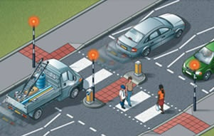
Correctly order the instructions below to help pedestrians to use this crossing safely.
Instruction | Order
Walk to the island looking both ways and listening
Step onto the second half of the zebra crossing
Stop at the island
Step onto the first half of the zebra crossing
Stop at the side of the road looking to the other side of the Zebra crossing
Look right
Look left
Wait until traffic from the right has stopped or the road is clear
Walk to the other side of the road looking both ways and listening
Stay on the island until traffic from the left has stopped or the road is clear

